**Productivity App**

19CSE445 - CLOUD COMPUTING

|  |  |
| --- | --- |
| Vaishakh Nambiar | BL.EN.U4CSE20192 |
| Veeksha S | BL.EN.U4CSE20195 |
| Vignesh GS | BL.EN.U4CSE20200 |
| Pusapati Ramakrishna Raju | BL.EN.U4CSE20134 |

**Abstract:**

The Productivity App is a comprehensive application designed to help individuals and teams increase their productivity and efficiency. The app includes a wide range of features, including a calendar, to-do list, priority list, assignee tracker, productivity tracker summary, and notification system. The calendar feature allows users to schedule events and tasks, while the to-do list and priority list help prioritize tasks based on importance. The assignee tracker allows users to delegate tasks to specific team members, while the productivity tracker summary provides a summary of individual and team productivity. Additionally, the notification system ensures that users are promptly informed of updates or changes to tasks or events. Overall, the Productivity App provides a complete solution for managing tasks, deadlines, and teams, making it an essential tool for businesses and individuals seeking to optimize their productivity.

**Design**:

The Productivity App is an AWS-based project designed to help increase productivity and efficiency for businesses. This app utilizes several AWS services including IAM, EC2, EBS, S3, CloudWatch, and SNS to create a comprehensive and reliable platform for users. The IAM service is used to manage access to resources and ensure secure authentication and authorization, while EC2 provides scalable compute capacity for running the app. The EBS service is utilized for block-level storage for EC2 instances, ensuring reliable and consistent performance. S3 is used for storing and retrieving data, allowing for easy and secure data transfer. The CloudWatch service provides monitoring and logging for the app, allowing for real-time analysis and troubleshooting. Finally, the SNS service is used for notifications and alerts to users, ensuring prompt responses to issues or updates. Overall, the Productivity App demonstrates the powerful capabilities of AWS services for building robust and scalable applications.

Software and tools:

* IAM
* EC2
* EBS
* S3
* CloudWatch
* SNS

**Architecture:**

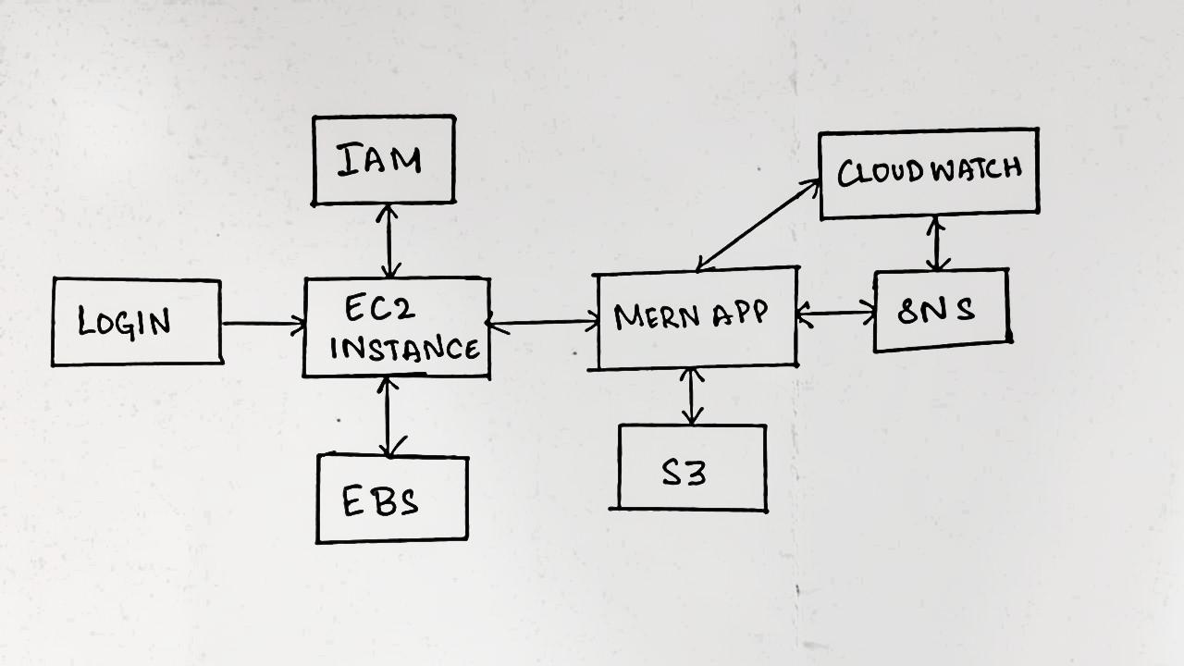

This is a client-server application which uses EC2 instances which uses IAM as role manager. The EC2 instance has EBS as its storage. ERN application is deployed in this instance which has S3 as its storage and CloudWatch for monitoring. SNS is used for notification systems